Rulebook Belgian OCR League Competition
Organizing club: De Sportstal
Date: 12/4/2026
Location: Langveldstraat 56 2220 Heist op den Berg
PARKING: Misweg 4 2220 Heist op den Berg
General Rules:
- Participants must perform each obstacle correctly according to the prescribed rules.
- If an obstacle is not carried out correctly, the penalties determined by the organization apply.
- Jurors and marshals are responsible for monitoring the performance.

- Log drag  Drag the bars  . Put the bar back where you took it. | 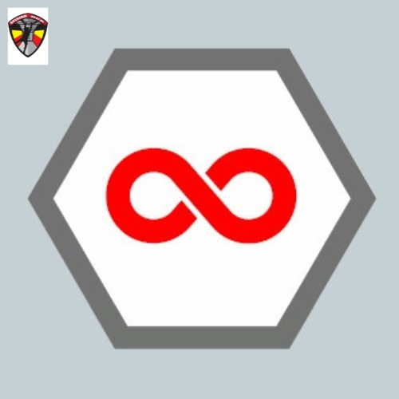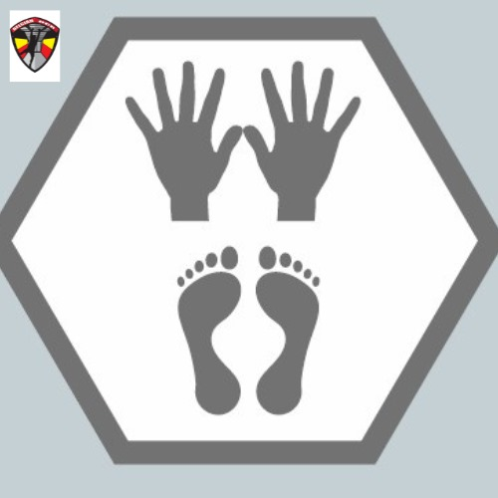  🟡 🟢 🔵 🔴
- Angled net  Go over the angled net. | 🟡 🟢 🔵 🔴
- Triangles + monkeysnake  Start  - via the rope.  Swing via the triangles and monkeysnake to the other side.  - Tap the bell of your own color | 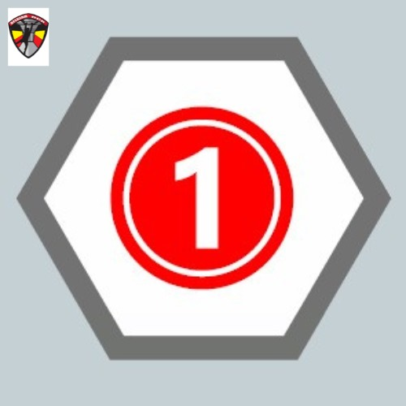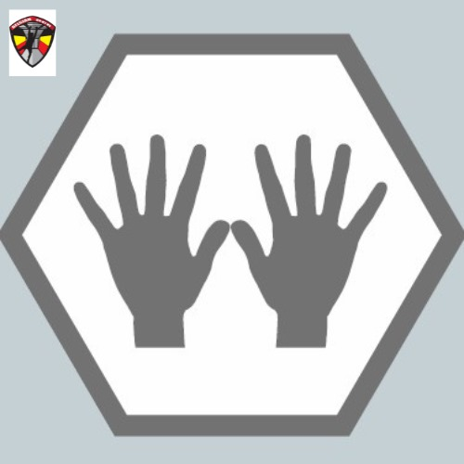 🟡 🟢 🔵 🔴
- Horizontal net + beam  Go under the horizontal net and beam  Start  - for the marking  End  - Tap the bubble of your own color. | 🟡 🟢 🔵 🔴
- Carry: sandbags

Carry the carry over the indicated course. DO NOT TOWhen you place the carry on the ground, you must resume from that point. Put the carry back in the provided compartment
- Hordes  Go over the 3 hurdles (adults with sandbag) | 🟡 🟢 🔵 🔴
- Monkey hang + lianas  Start  - Start before the marking  Go along the bottom of the rope and the vines to the other side, without touching the ground!  - Tap the bell of your own color | 🟡 🟢 🔵 🔴
- Weaver  🟡 🟢 Are about the weaver.  Start by going over the first horizontal bar.  2nd bar you go under. Go over and under the bars to the end. Feet should not touch the ground at any time. | 🟡 🟢 🔵 🔴
- Rope Climb  Climb on the rope and  - Tap the bell (yellow and green)  - Do a swing over (blue, red and adults) | 🟡 🟢 🔵 🔴
- Grip Lane with buoys  Start  - via the rope.  Use the grips to go to the other side. Feet should NOT be used  - Tap the bell of your own color  🟡 🟢 Turn off here and walk straight to obstacle 16 | 🟡 🟢 🔵 🔴
- Wall with beams  Go over the top bar. | 🔵 🔴
- Grip Lane with wooden discs  Start  - via the rope.  Use the grips to go to the other side. Feet should NOT be used  - Tap the bell of your own color | 🔵 🔴
- Wall / vertical wall and sloping wall  Go over the wall verial wall.  Go under the sloping wall. | 🔵 🔴
- Double ''fixed' dipwalk  Start  - with hands for marking  Use hands to move forward. Feet should NOT be used  Adults perform both dipwalks.  Youth just small dipwalk  - finish with hands past the 2nd/back mark.  Then carry car tire. (adults only) | 🔵 🔴
- Atlas stones
Raise 1 ball over the fence.
Different weight men and women.
- Step loops and lianan  Perform the step loops and lianas up to the bell. (Same bell for everyone. White bell) | 🟡 🟢 🔵 🔴
- Monkey bars with low ring  Start  - via the rope.  Go via the monkeybars and possibly the low ring to the other side and  - Tap the bell of your own color  Monkeybar in front of and behind the ring may not be used! (This will be made clearly visible)  If possible, the ring can be skipped! | 🟡 🟢 🔵 🔴
- Rings  Start  - On the beam.  Go through the rings to the other side and  - tap the bell (Same bell for everyone. White bell) | 🟡 🟢 🔵 🔴
- Grip Lane (ovals)  Start  - via the rope.  Use the grips to go to the other side. Feet should NOT be used. (Only with the rope)  - Tap the bell of your own color | 🟡 🟢 🔵 🔴
- Crawl: net  It is not allowed to leave the obstacle from the side.  Get under the net. You get a line on your hand for your next round.  🟡 🟢 Get under the net, end of the game (possibly execute penalty first) | 🟡 🟢 🔵 🔴
- Log drag  Drag the bars.  Put the bar back where you took it. | 🔵 🔴
- Angled net  Go over the angled net. | 🔵 🔴
- Grips and waveboard  Start  - via the rope.  Swing via the grips and waveboard to the other side.  - Tap the bell of your own color | 🔵 🔴
- Horizontal net + beam  Go under the horizontal net and beam  Start  - for the marking  End  - Tap the bubble of your own color. | 🔵 🔴
- Carry: sandbags
Carry the carry over the indicated course. DO NOT TOWhen you place the carry on the ground, you must resume from that point. Put the carry back in the provided compartment/box
- Hordes  Go over the 3 hurdles (adults with sandbag) | 🔵 🔴
- Low to high  Start  - Behind the ribbon  Use the grips, rings,... to go to the other side. Feet should not touch the suspension of the grips at any time or seek support against it!  Only with low-hanging grips/rings may the suspension rope be touched/used.  - Tap the bell. | 🔵 🔴
- Flying monkey bar  Start  - on the beam  Use the monkey bar to go to the other side. Feet should NOT be used  - Tap the bubble of your own color. | 🔵 🔴
- Rope Climb  Climb on the rope  - Do a swing over (blue, red and adults) | 🔵 🔴
- Spinners and wingnut  Start  - via the rope.  Use the wingnut to go to the other side. Feet should NOT be used  - Tap the bell of your own color  🔵 Turn off here and walk straight to obstacle 36 | 🔵 🔴
- Wall with beams  Go over the top bar. | 🔴
- Grip Lane (hammers, saucers, cones)  Start  - via the rope.  Use the grips to go to the other side. Feet should NOT be used  - Tap the bell of your own color | 🔴
- Wall / vertical wall and sloping wall  Go over the vertical wall.  Go under the sloping wall. | 🔴
- Double ''fixed' dipwalk  Start  - with hands for marking  Use hands to move forward. Feet should NOT be used  Adults perform both dipwalks.  Youth just small dipwalk  - finish with hands past the 2nd/back mark.  Then carry car tire. (adults only) | 🔴
- Atlas stones
Raise 1 ball over the fence.
Different weight men and women.
- Labyrinth  Start  - On the platform  Use the pegs (with ball) to perform the labyrinth.  - Starting with both pegs in the first 2 holes  - End up with both pegs in the last 2 holes (past the indicated line)  🔵 Beyond the indicated line. (This is less far than 🔴 and adults  A volunteer brings back the pegs. | 🔵 🔴
- Net + lowrig  Start  - On the rope behind the line.  Use the grips, rings,... to go to the other side. Feet should not touch the suspension of the grips at any time or seek support against it!  Only with low-hanging grips/rings may the suspension rope be touched/used.  - Tap the bubble of your own color. | 🔵 🔴
- Grip Lane (wheel, flyingboard, ...)  Start  - On the beam.  Use the grips to go to the other side. Feet should NOT be used  - Tap the bell of your own color | 🔵 🔴
- Twister + grips  Start  - On platform  Continue without using your feet.  - Tap the bell of your own color | 🔵 🔴
- Crawl: net  It is not allowed to leave the obstacle from the side.  Get under the net, end of the game (possibly execute penalty first) | 🔵 🔴

